1. Name of employee who work in deptno with the job_id use last_name column.

Soln: select last_name,job_id,department_id from employees;

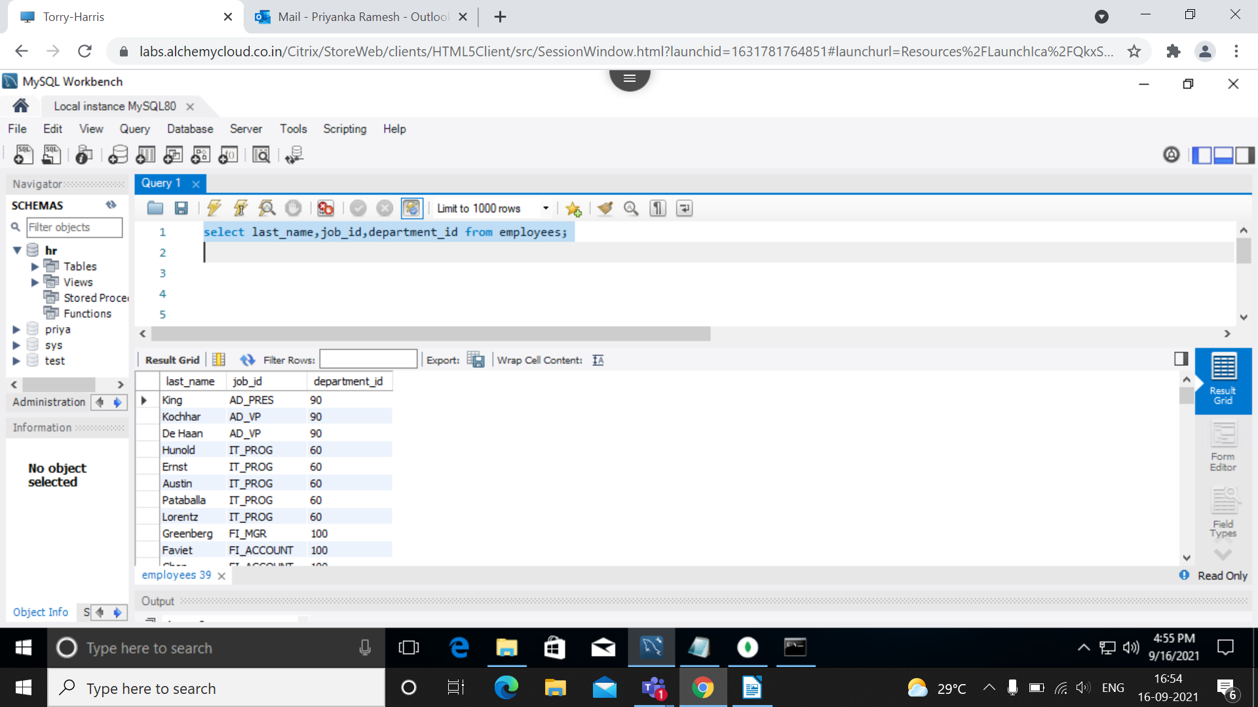

2. Employees who joined in the year 2000.

soln: select employee_id, first_name,last_name, hire_date from employees where date_format(hire_date,"%Y") = '2000';

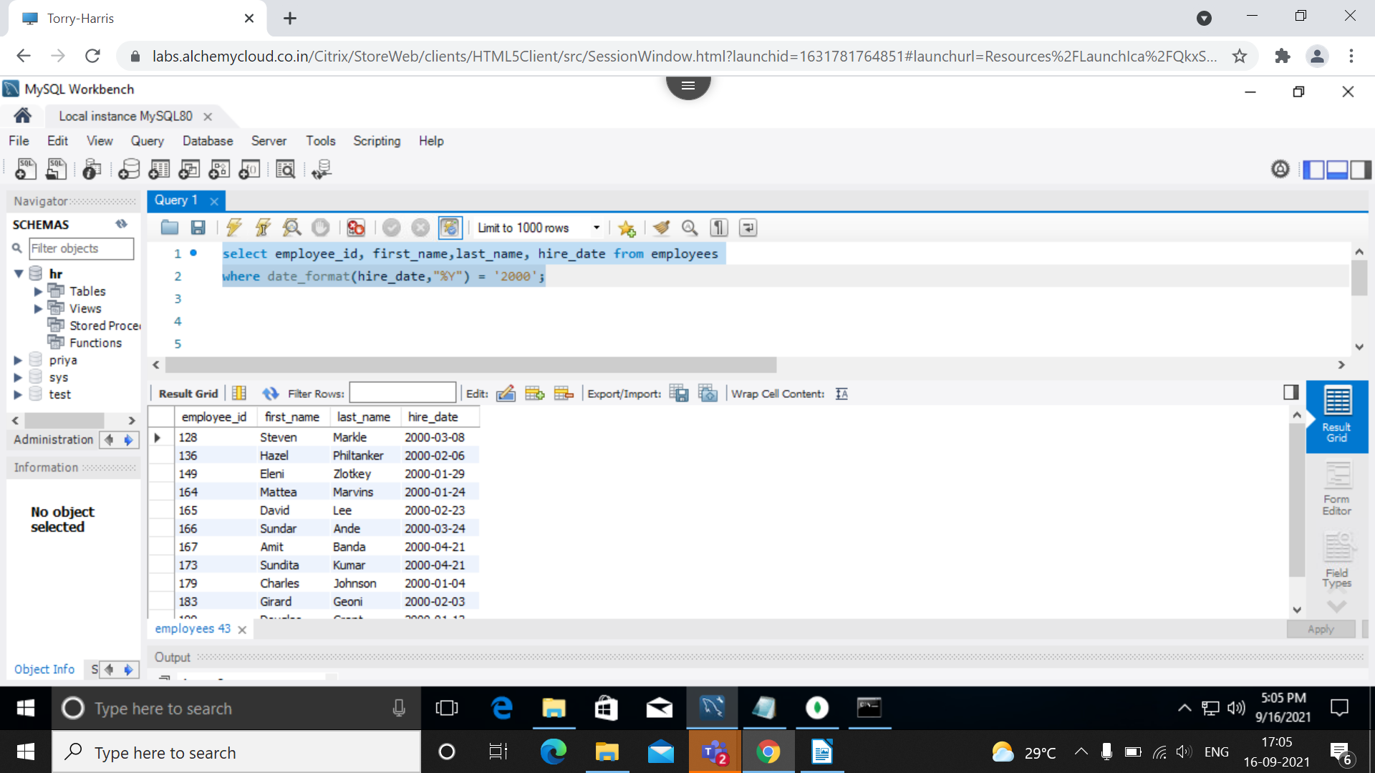

3. Employees who joined after jan_1996.

select * from employees where hire_date > ('1996-01-31');

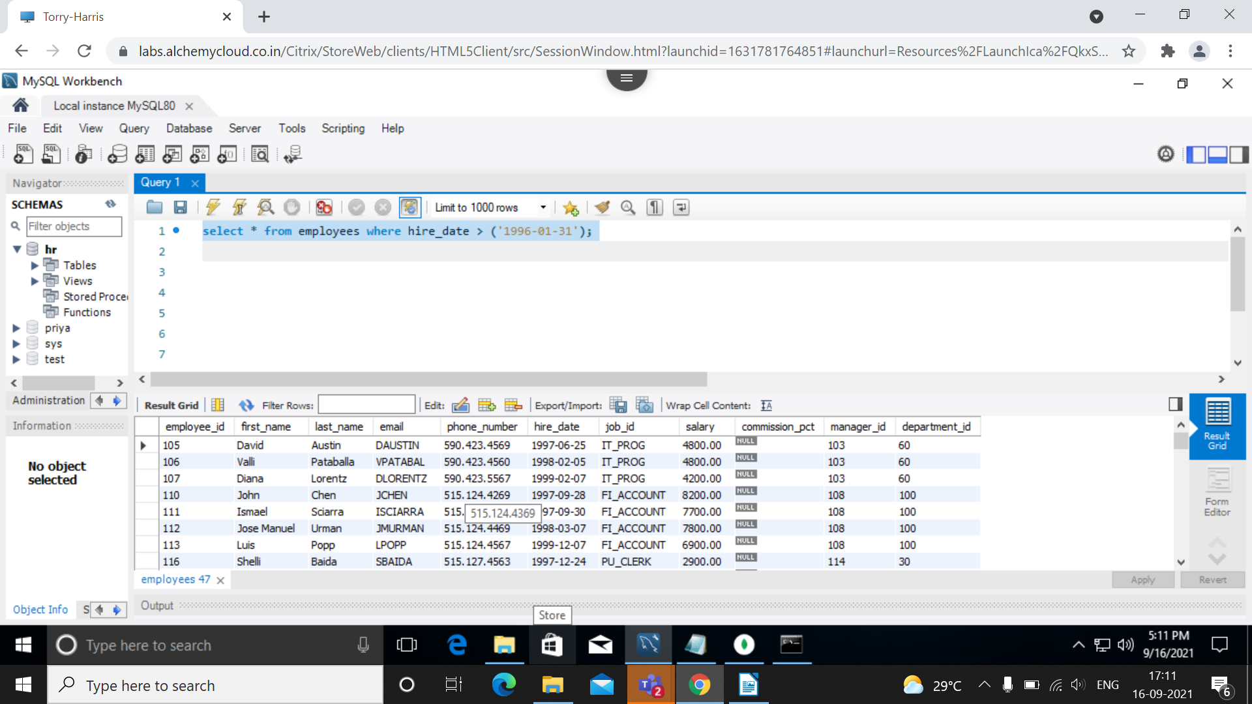

4. Employees whose name starts between ‘S’ to ‘R’.

soln: select employee_id, first_name, last_name from employees where first_name like "s%" and last_name like "%r" ;

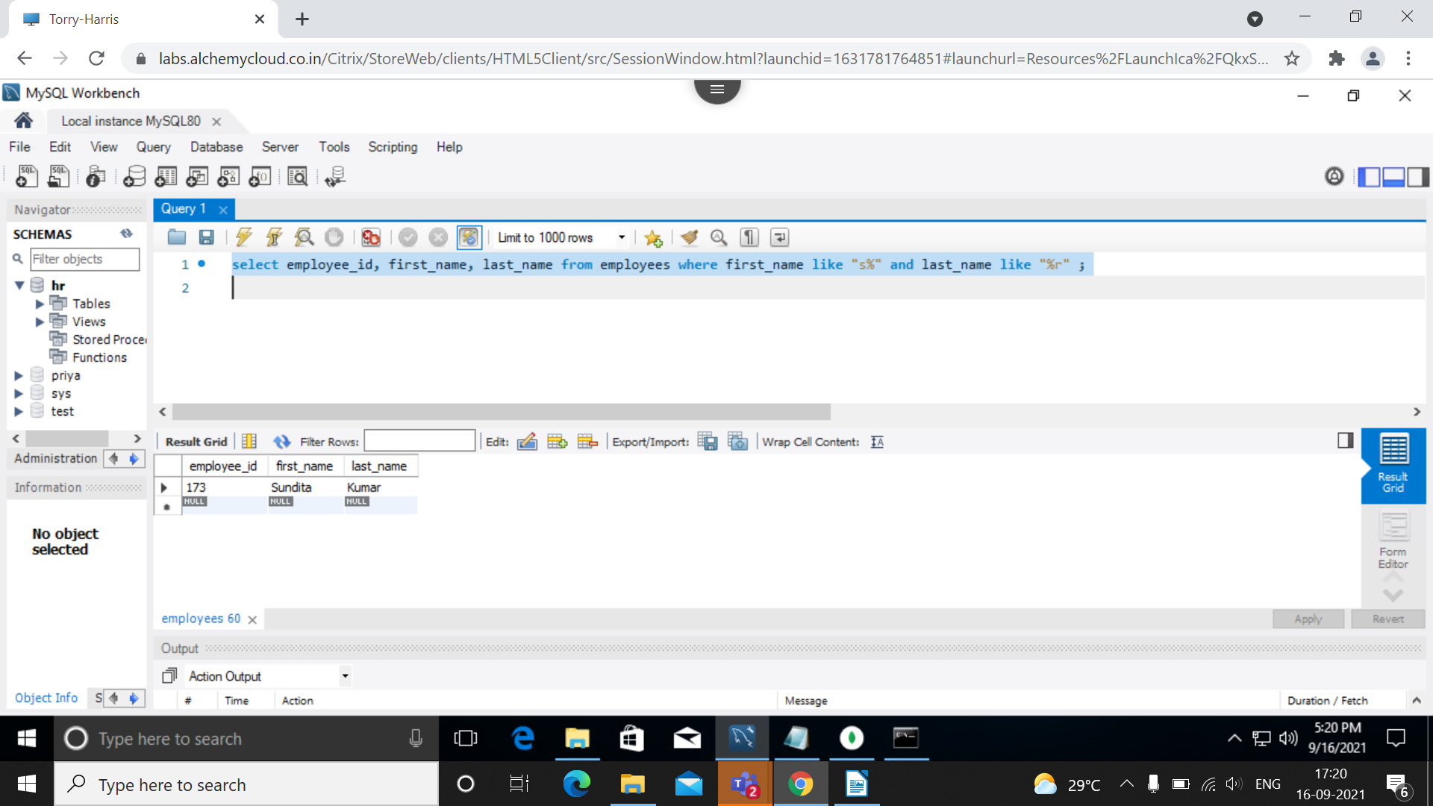

5. Employees who works under manager_id(200,201)

soln: select employee_id, first_name, last_name, manager_id from employees where manager_id between 200 and 201;

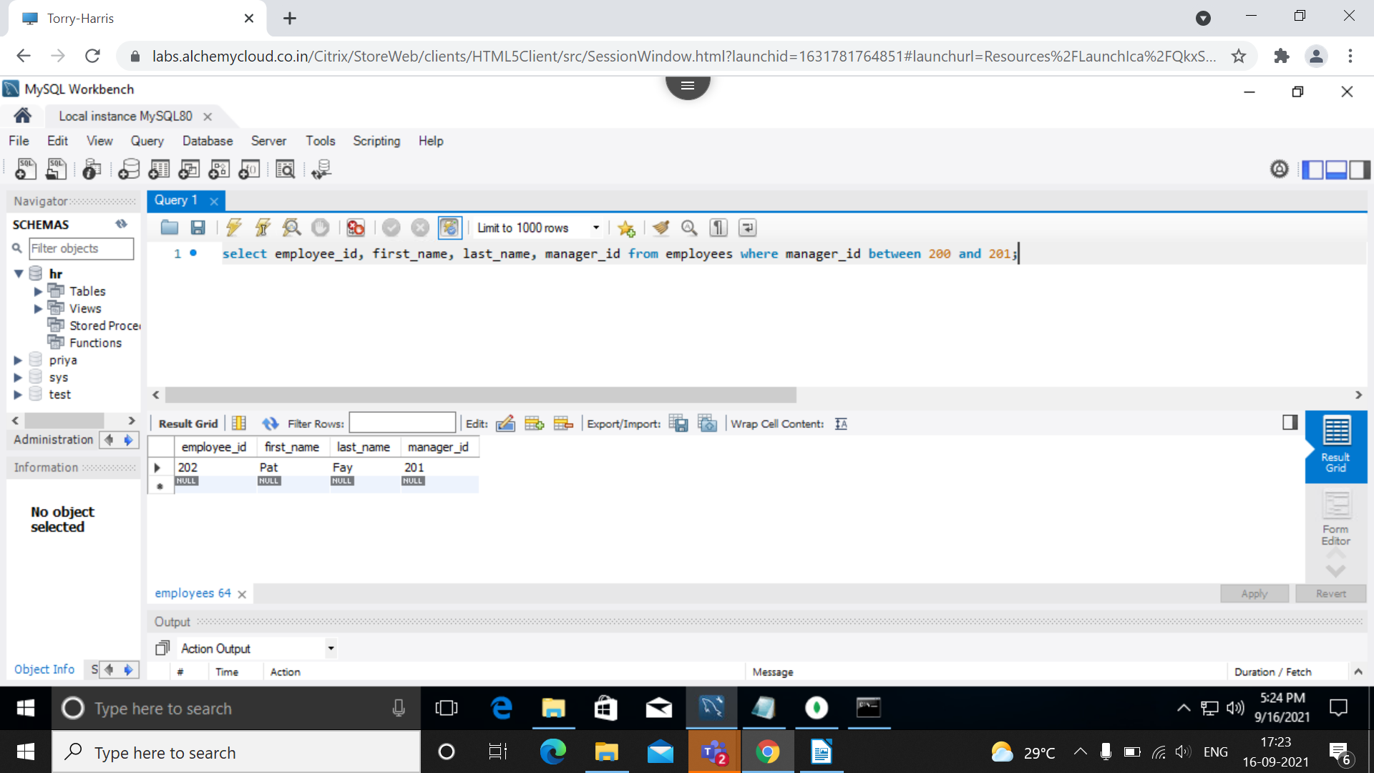

6. Employees who are “REP” or “MAN” and who are paid more than 6000.

soln:

select employee_id, first_name, job_id from employees where (salary>6000 and (job_id like "%REP" or job_id like "%MAN"));

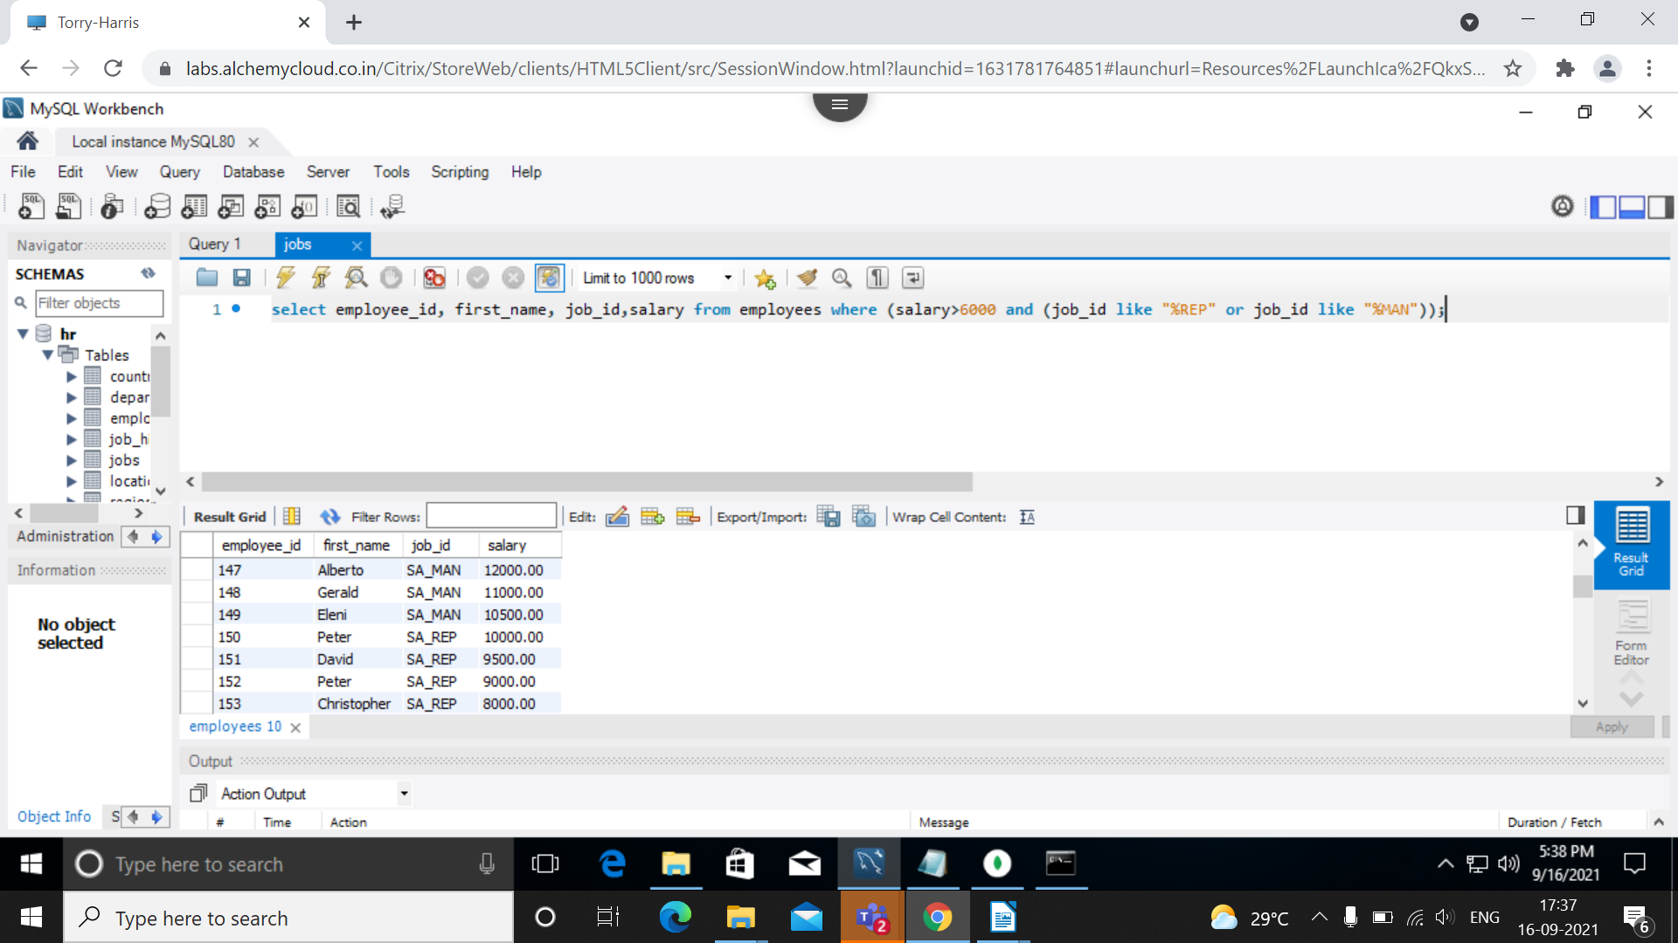

7. Calculate annual salary of each employee and print them in descending order.

Soln:

select last_name,department_id, salary*12 annualsal from employees order by annualsal desc;

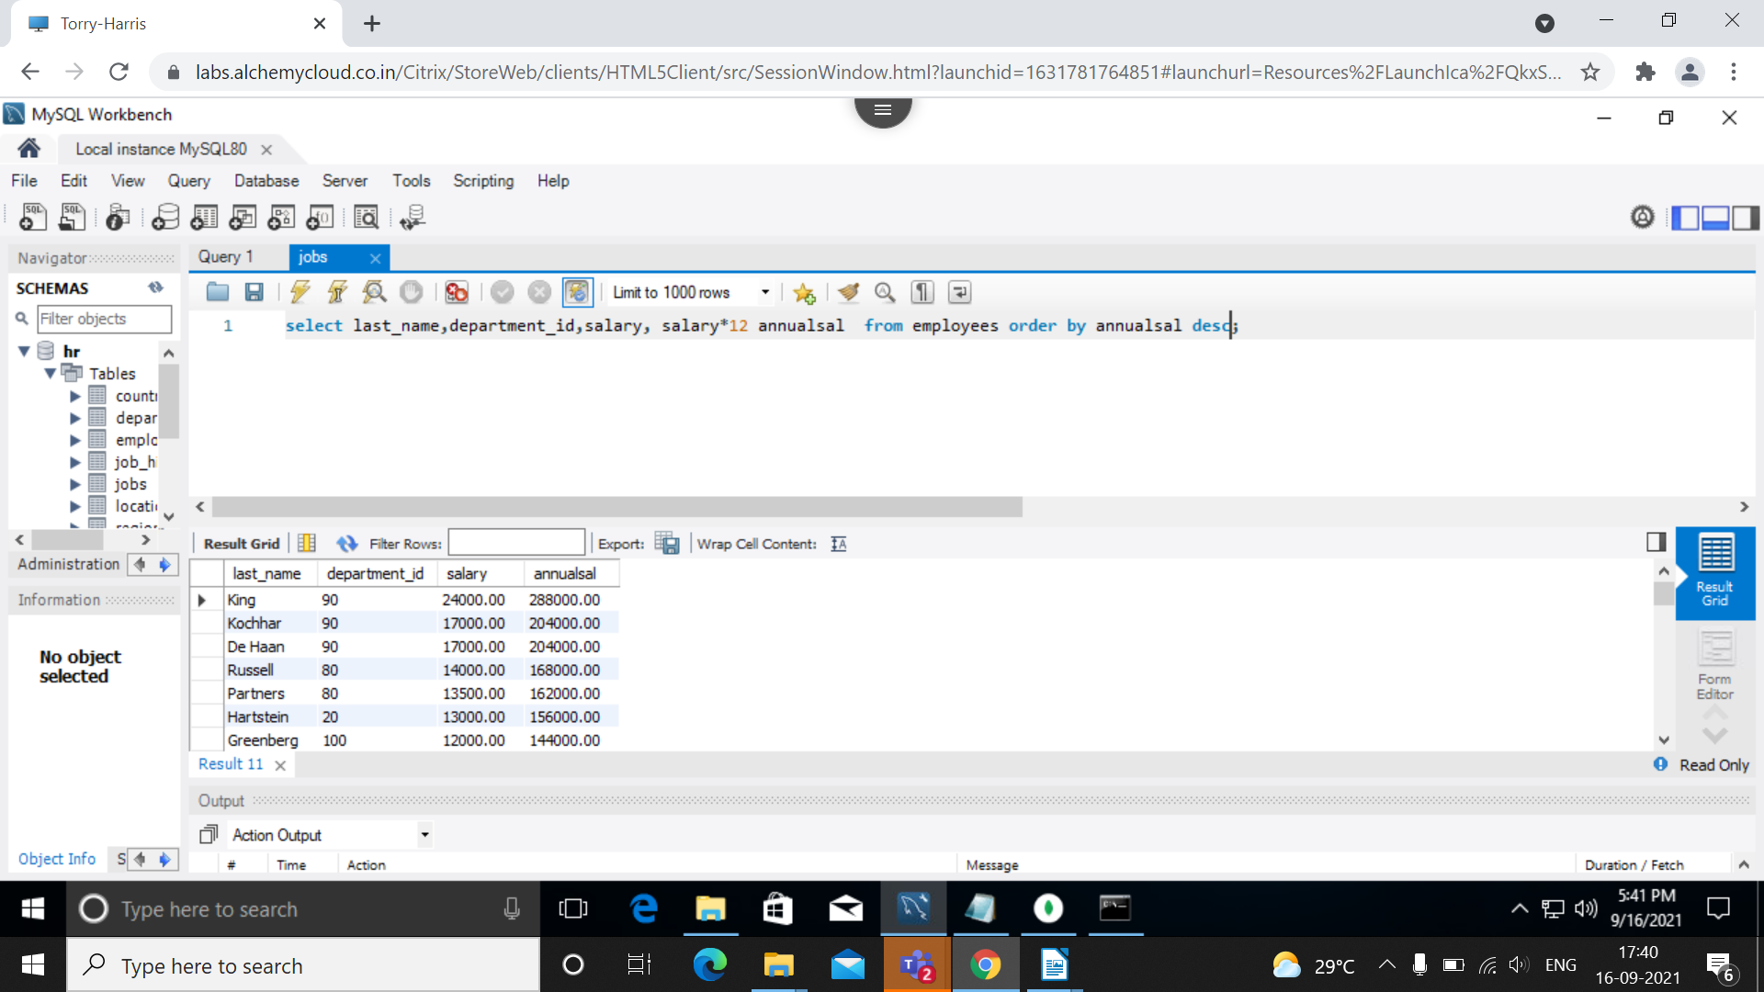

8. Replace the last_name of “Landry” to “JOE” in the employee table.

Soln:

select employee_id,first_name,last_name, replace(last_name,last_name,"JOE") from employees where last_name='Landry' ;

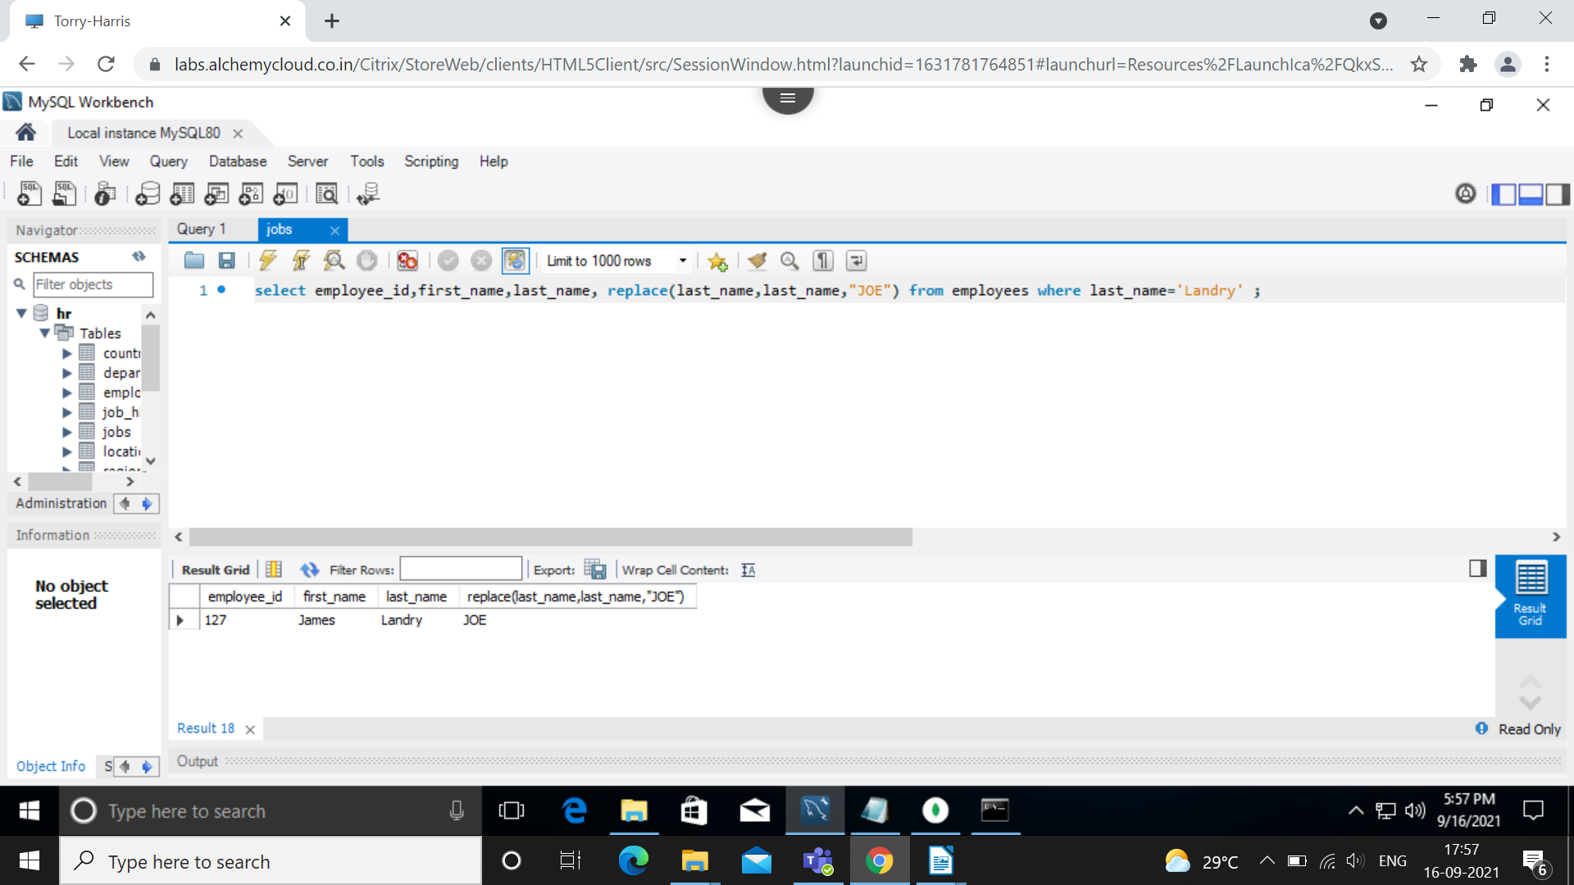

9. Find the position of first occurrence of the character ’o’ in the last_name of all employees who have ‘o’ in their last name.

Soln: select last_name, position("o" in last_name) Occurrence from employees where position("o" in last_name) >0;

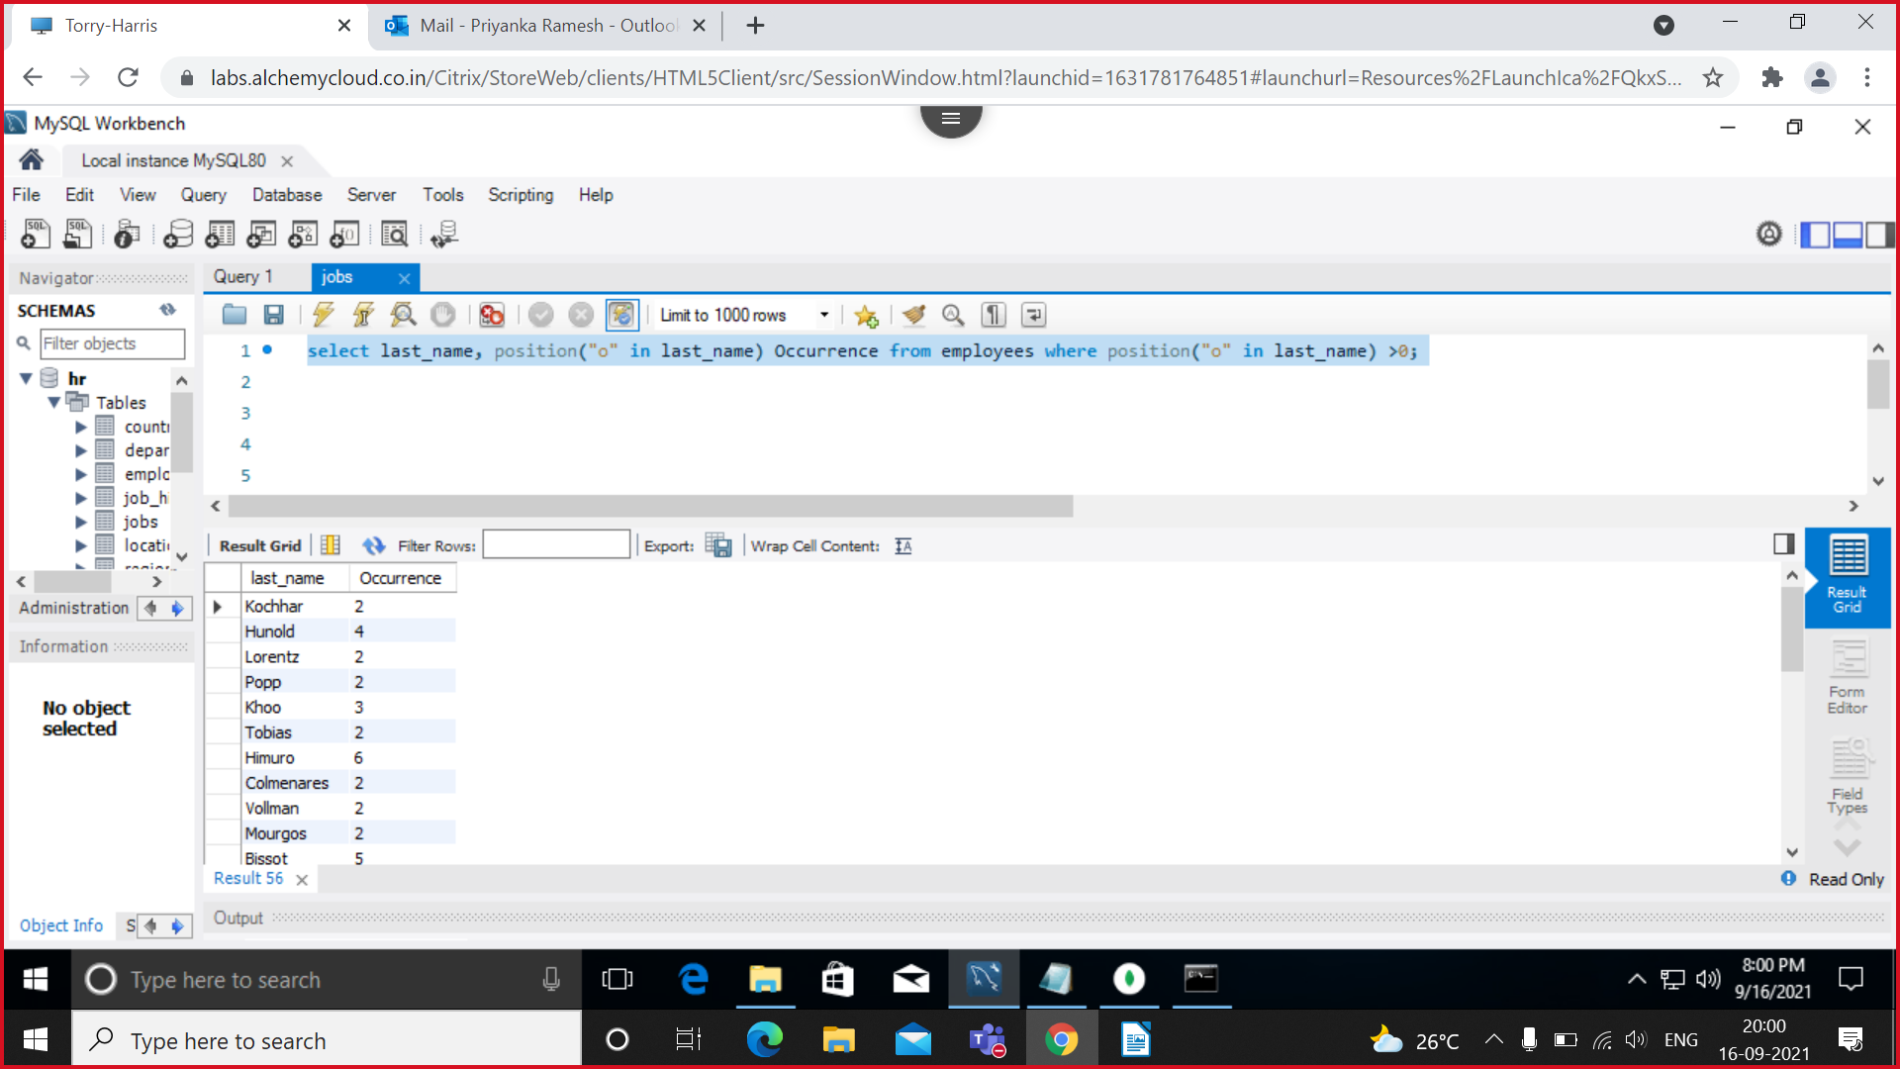

10. Prefix “2020_B84” for employee last_name who works in department 90.

Soln:

select last_name, department_id, lpad(last_name,9+length(last_name),"2020_B84 ") from employees where department_id=90;

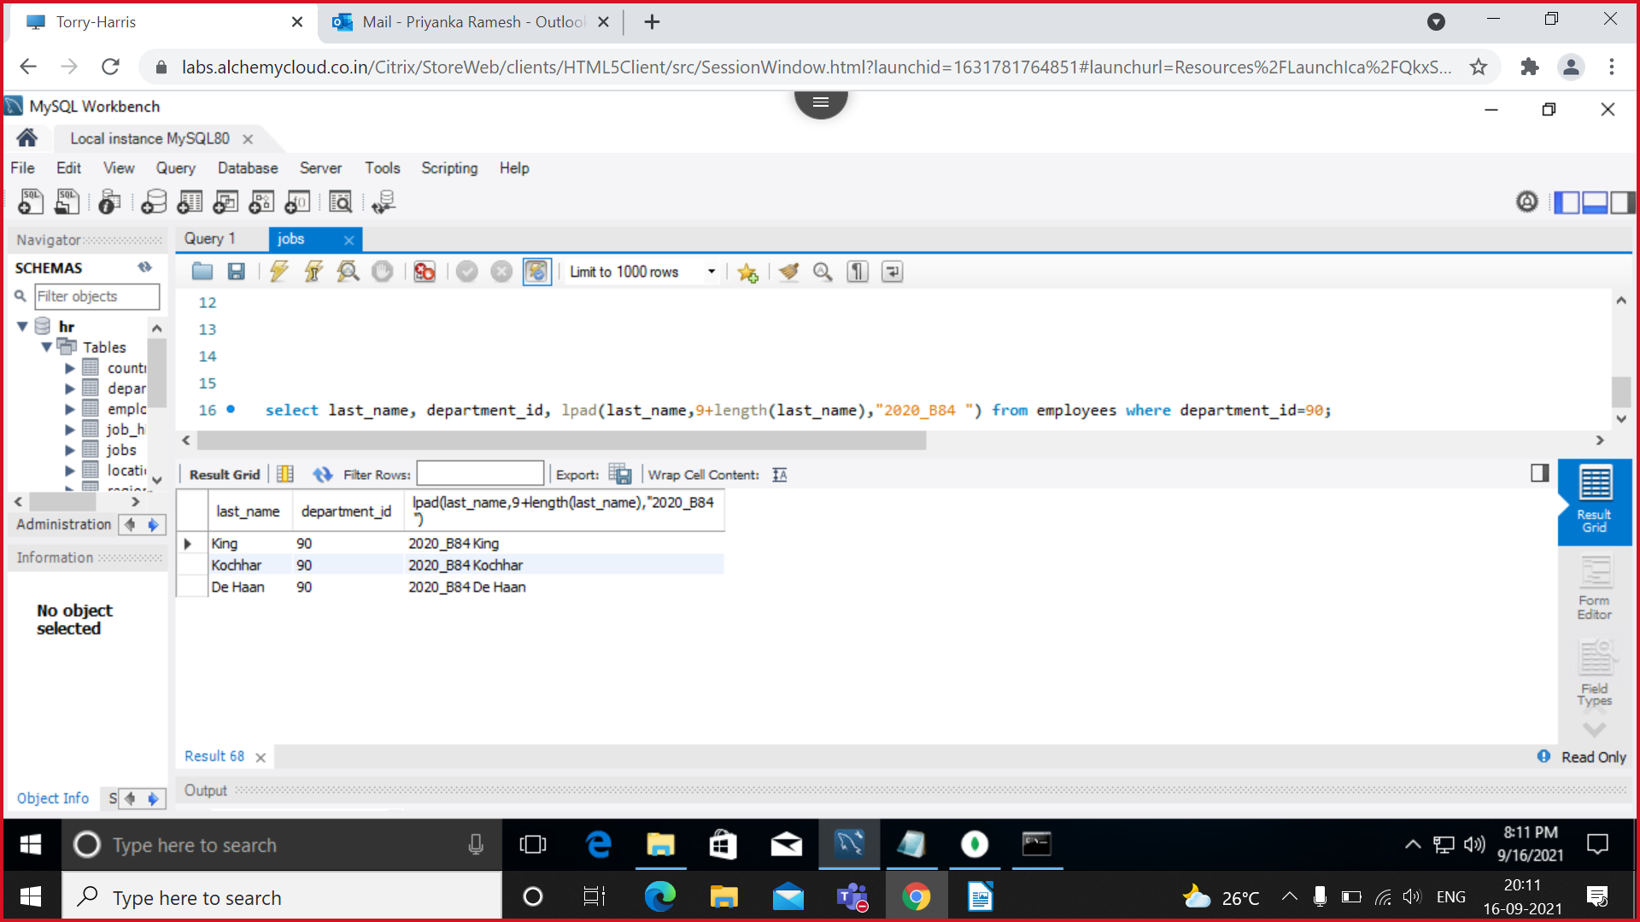

11. Find the current date with local date and time.

Soln: select current_timestamp(); **OR** select now() "current_timestamp";

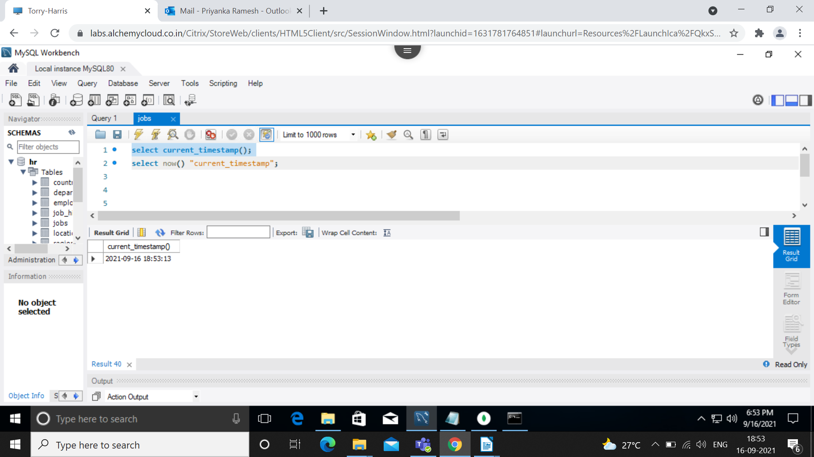

12. Find the average commission paid for all the employees(ignoring null entries).

Soln: select avg(commission_pct) from employees where commission_pct is not null;

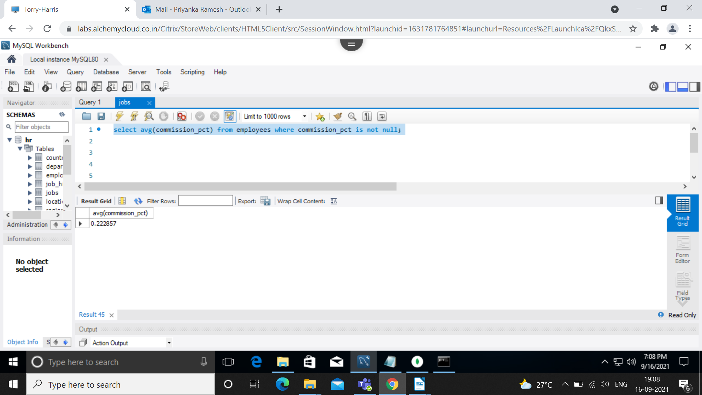

13. Find the average and highest salary paid for department 80,90,100.

soln:

select department_id, max(salary),avg(salary) from employees where department_id between 80 and 100 group by department_id;

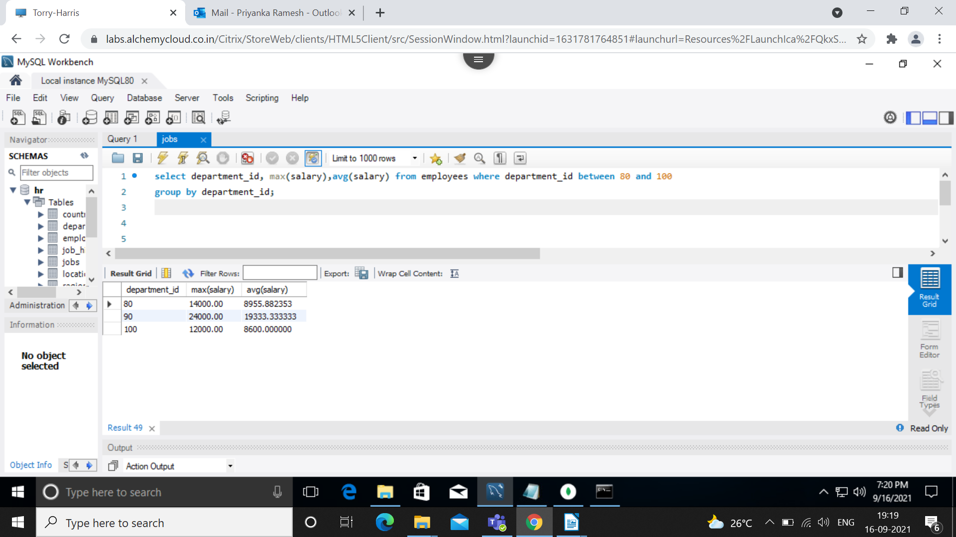

14. Find the department id where the highest paid employee salary is more than 1000.

soln:

select department_id, max(salary) from employees where salary>1000 order by department_id desc;

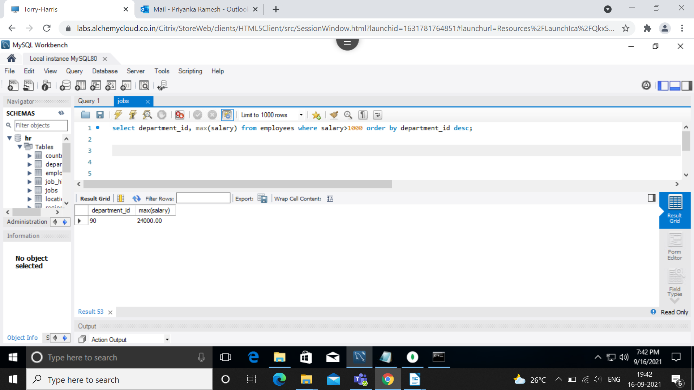

15. Find the department-id who is paid the maximum average salary in the organization.(Use subqueries).

Soln:

select max(sal) from(select avg(salary) sal from employees group by department_id) as result;

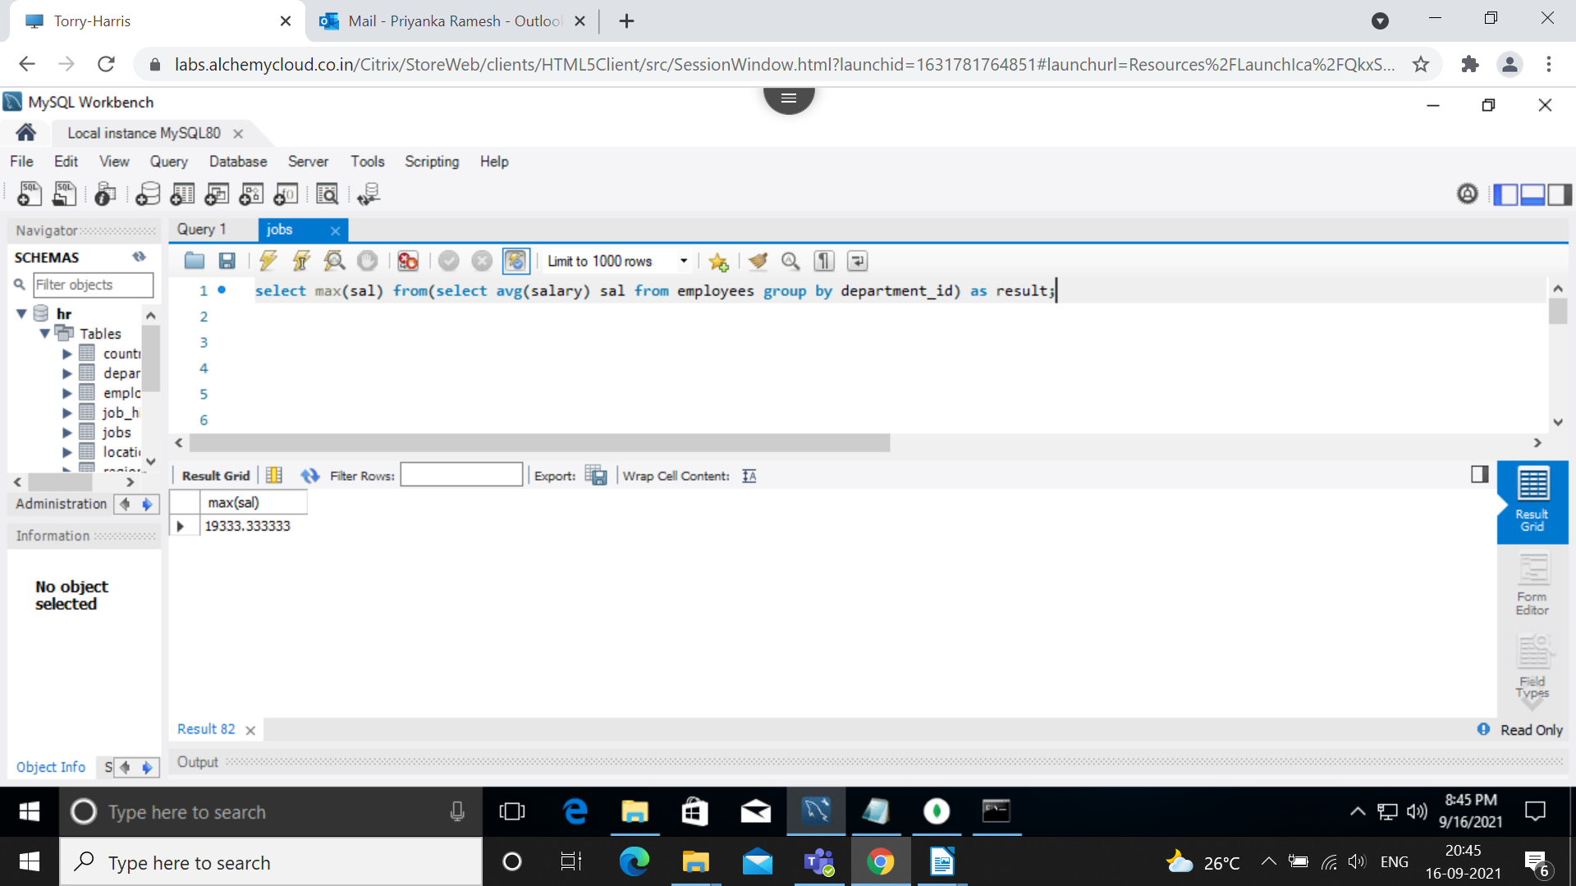

16. Find the department_name, location_id in which last_name=’Ernst’.

Soln: select department_name, location_id,last_name from departments , employees where last_name='Ernst';

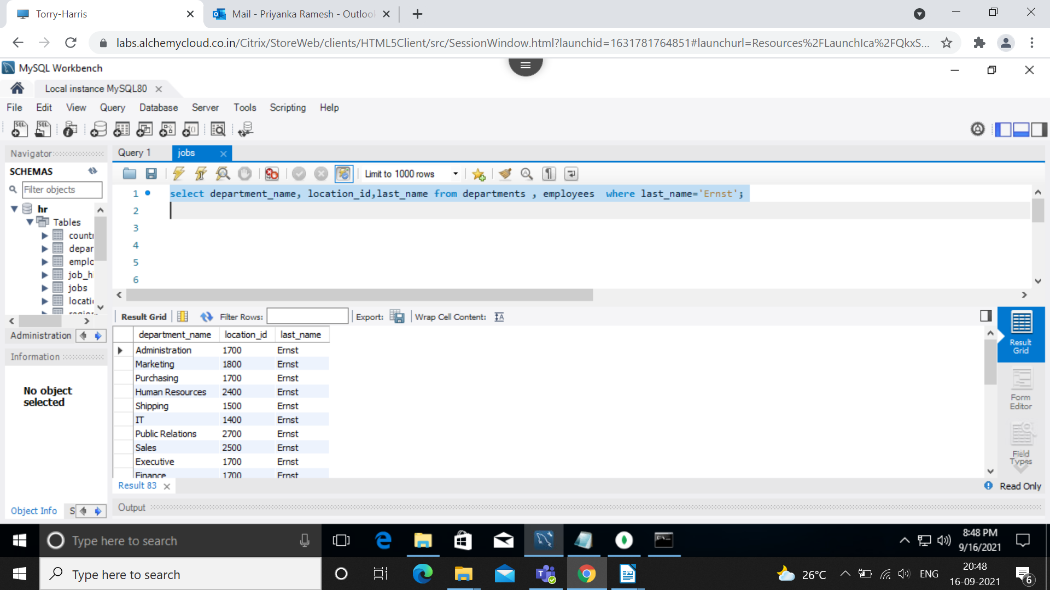

17. Find all the employee names who work in TOKYO city.

Soln:

18. Find the employee names who are the maximum paid salary in the organization.

Soln:

select employee_id,first_name,last_name,salary from employees where salary=(select max(salary) from employees);

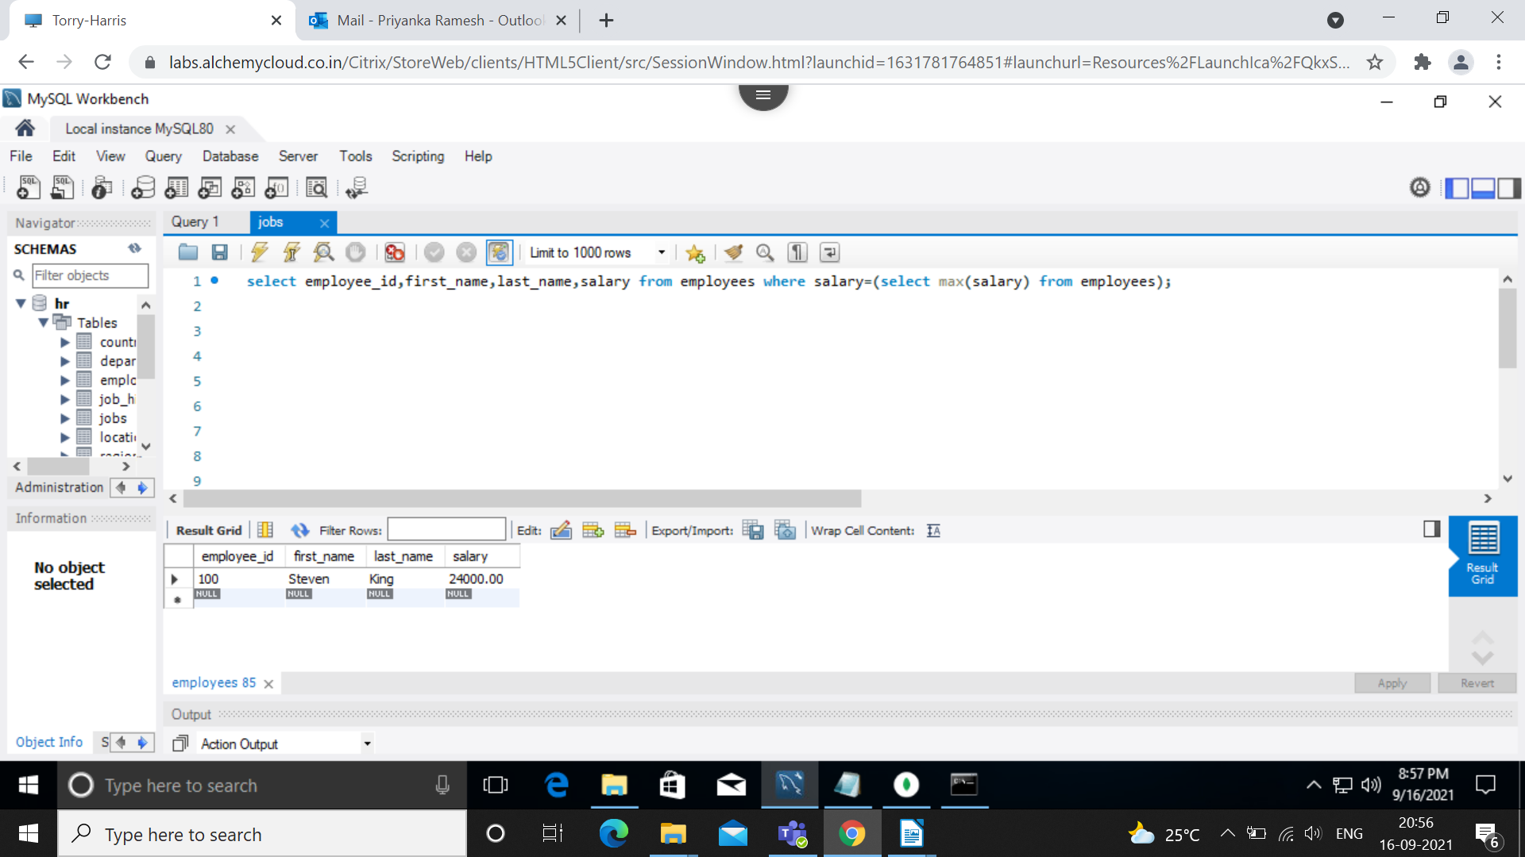

19. Find the employees who are drawing minimum salary in their respective departments.

Soln: select last_name,department_id,job_id, min(min_salary) from  
(select e.first_name,e.last_name,e.department_id,e.job_id,j.job_title,j.min_salary from employees e inner join jobs j on e.job_id=j.job_id) as joined group by department_id;

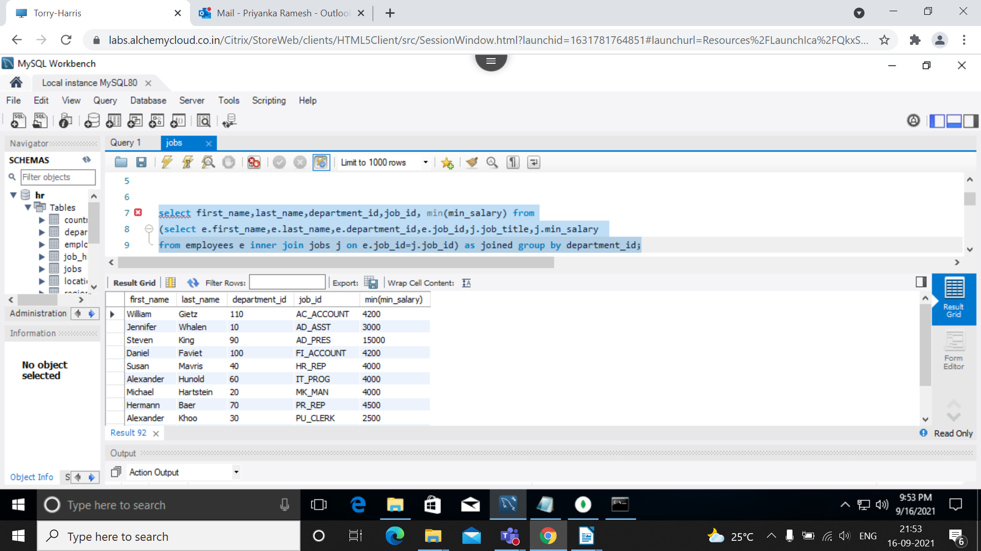

20. Find the employee names and their job_id and job_titles by joining employees and jobs table

Soln: select e.first_name,e.last_name,e.job_id,j.job_title from employees e inner join jobs j on e.job_id=j.job_id;

